**Day 14 Task: Python Data Types and Data Structures for DevOps**

**Tasks**

1. Give the Difference between List, Tuple and set. Do Hands-on and put screenshots as per your understanding.

Solution -   
  
List

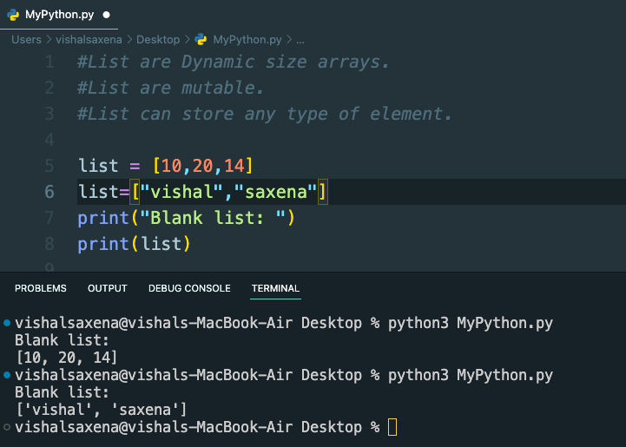

Tuple

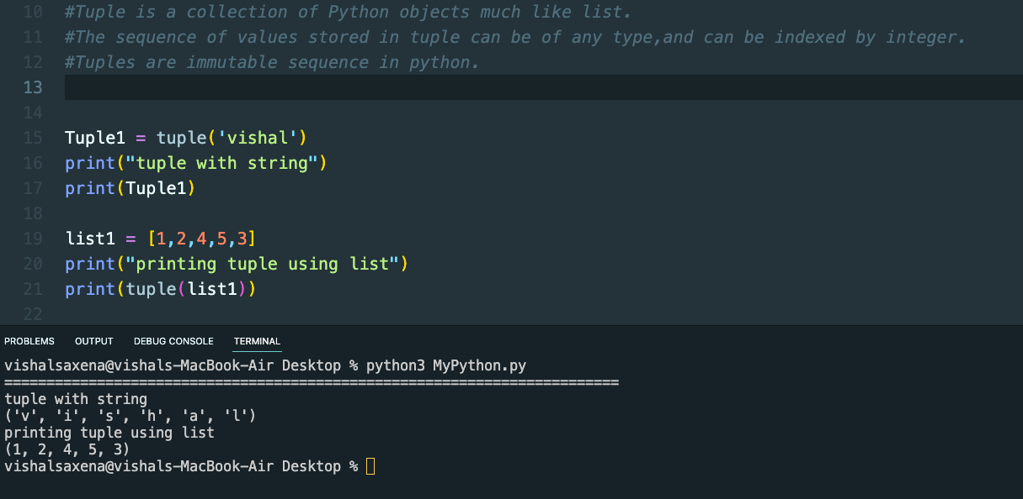

Set

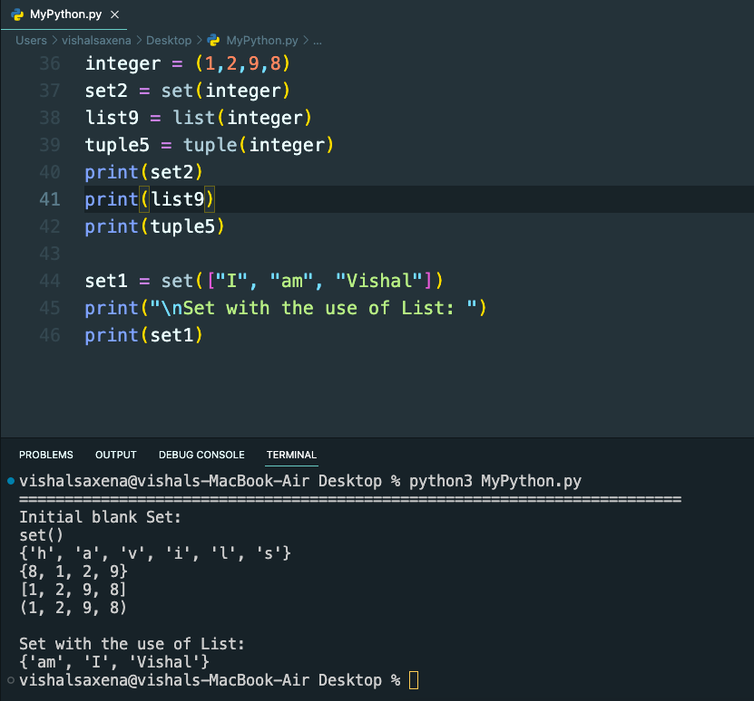

In Python, a list is a collection of items that are ordered and changeable. Lists are written with square brackets and items are separated by commas.

A set is a collection of items that are unordered and unchangeable. Sets are written with curly braces and items are separated by commas. Sets are useful when you want to make sure that there are no duplicate items in your collection.

A tuple is a collection of items that are ordered and unchangeable. Tuples are written with parentheses and items are separated by commas. Tuples are useful when you want to ensure that the items in your collection are not modified by mistake.

In summary:

* Lists are ordered and changeable
* Sets are unordered and unchangeable
* Tuples are ordered and unchangeable

2. Create below Dictionary and use Dictionary methods to print your favourite tool just by using the keys of the Dictionary.

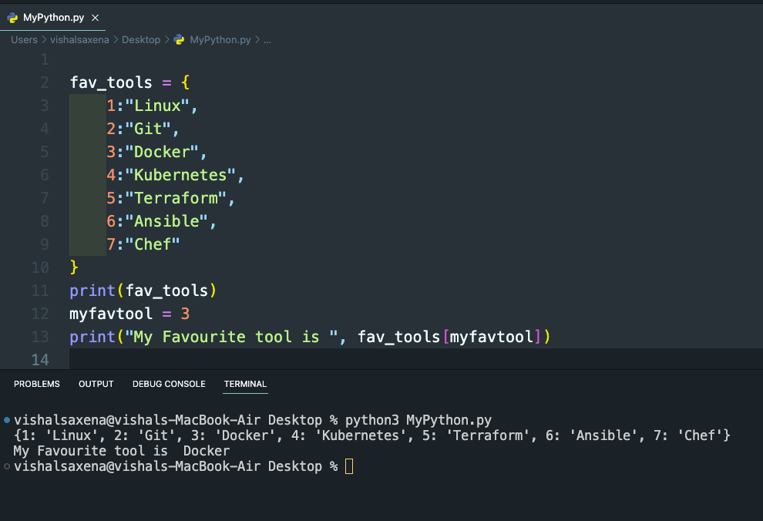

1. Create a List of cloud service providers   
   eg.cloud_providers = ["AWS","GCP","Azure"]

Write a program to add Digital Ocean to the list of cloud_providers and sort the list in alphabetical order.

